Karen Macken, Dietitian Manager 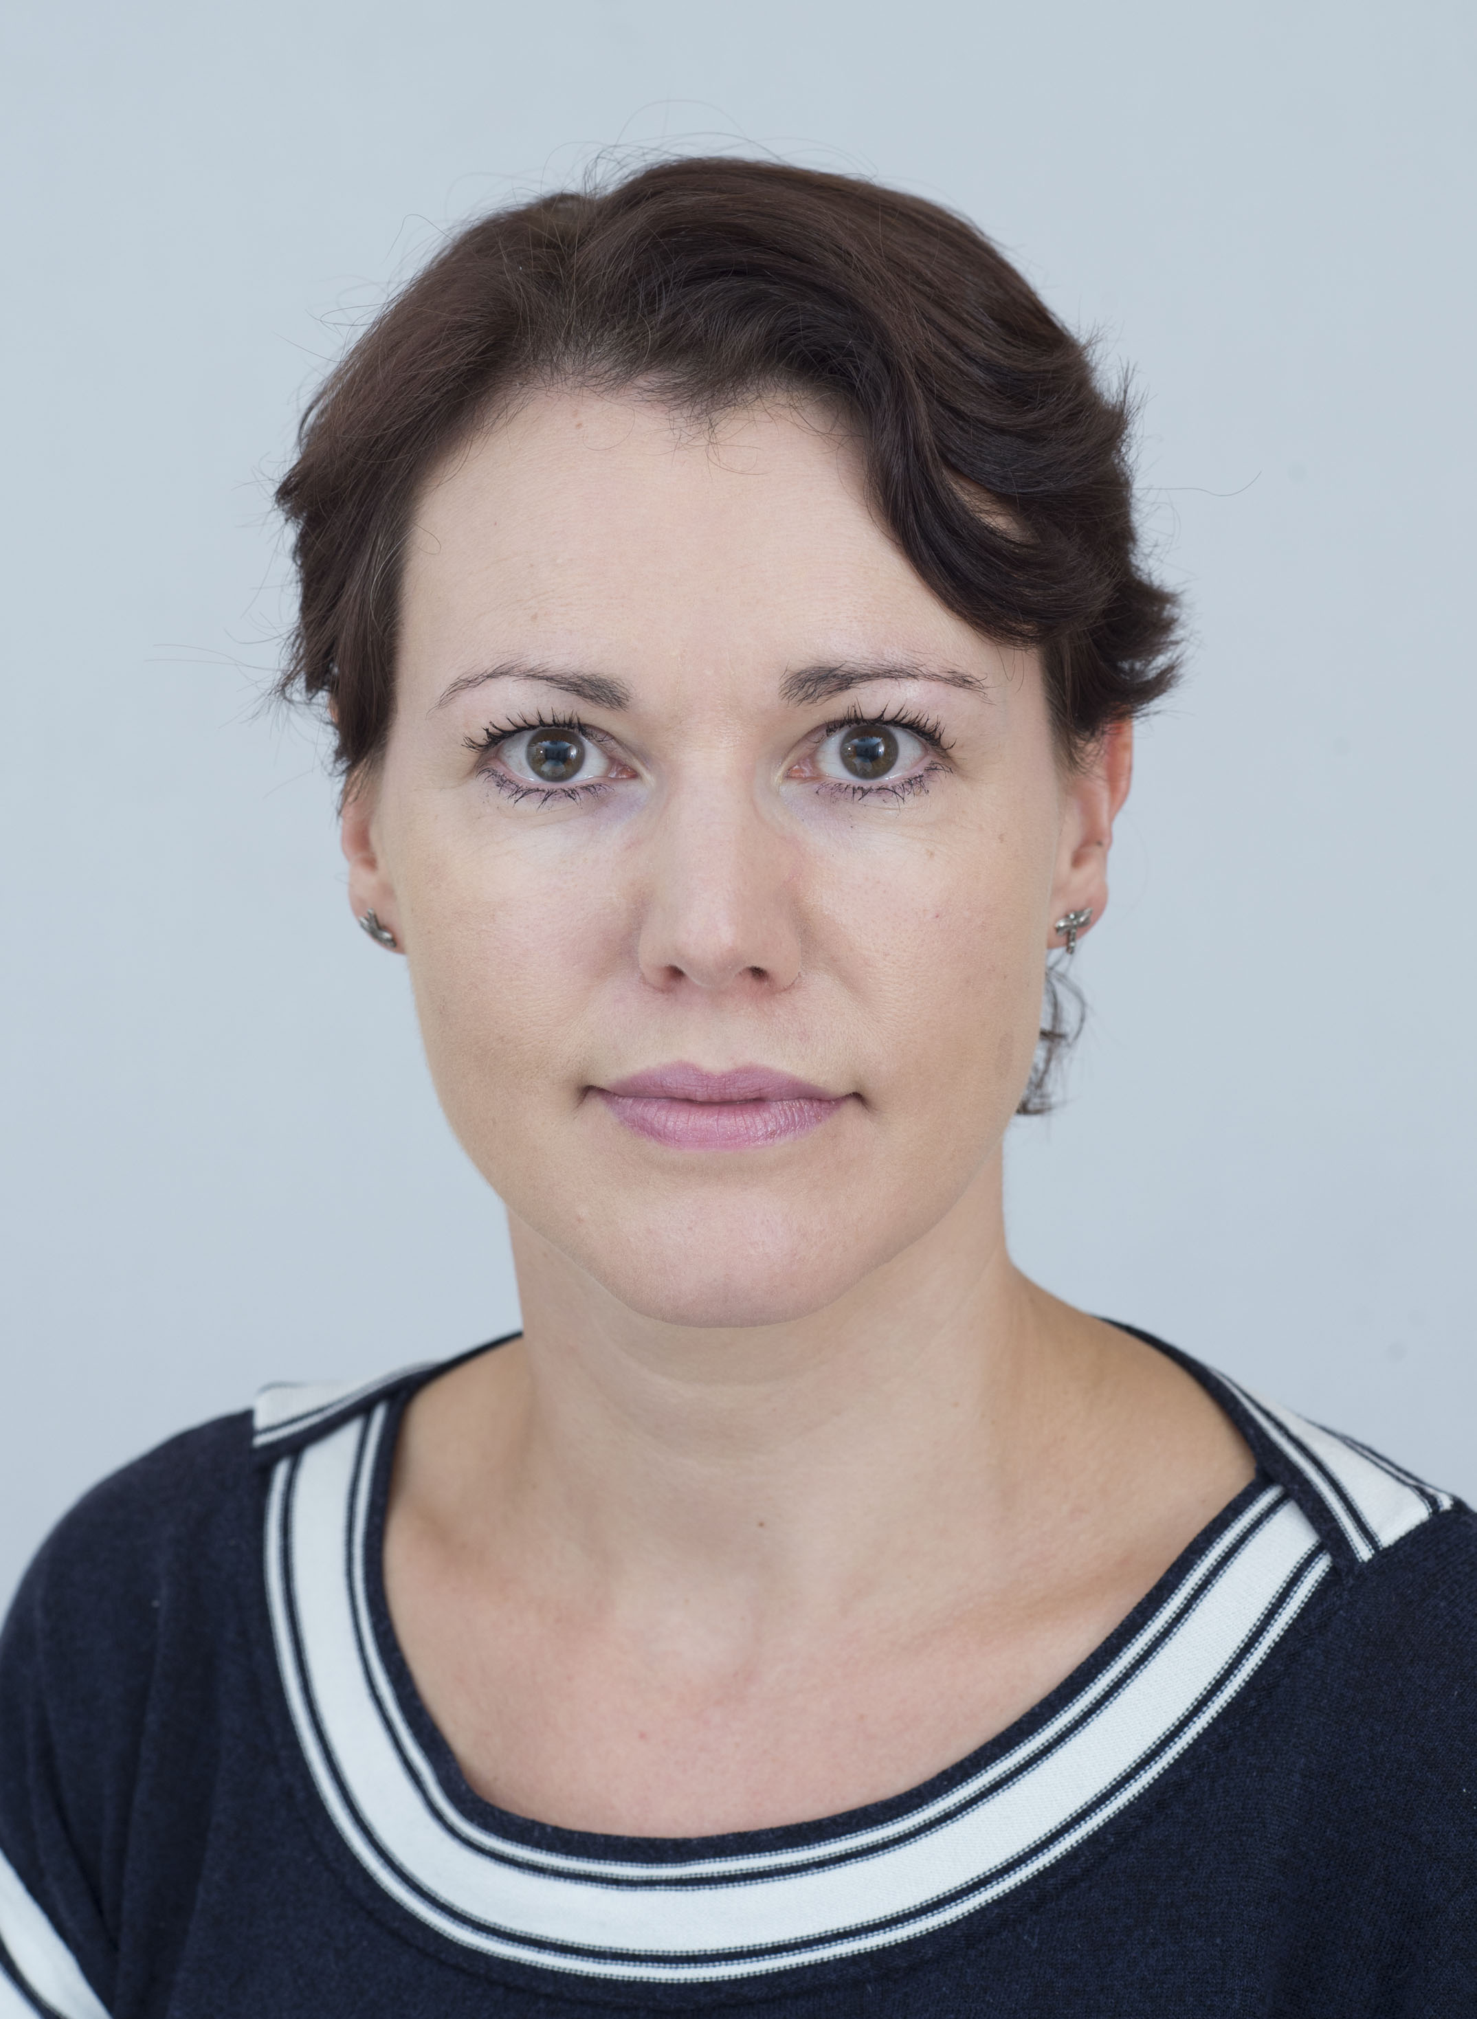

Graduated in 1995 with a degree in Nutrition & Dietetics, Karen has subsequently undertaken additional qualifications in Healthcare Management; Psychology; and professional development courses in Interpersonal Skills Training; Motivational Interviewing; Cognitive Behaviour Therapy for Dietetics; Group facilitation; Obesity management; Intuitive Eating, and the low FODMAP diet.

Karen has significant experience in a variety of dietetic specialities for acute inpatient, oncology, gastroenterology, hospice care, and outpatient services. She joined the Bon Secours dietetic team in 2007. In addition to managing the service, she has a special interest in gastroenterology, and in the psychological complexity of eating difficulties and weight management. She works to empower individuals who may be struggling to manage their weight and helps them to regain control of their eating behaviours.

She is an active member of the Irish Nutrition & Dietetic Association (INDI), the Irish Society of Parenteral and Enteral Nutrition (ISPEN), the British Dietetic Association (BDA).

